Names of Group Members:

1. What are the benefits / weaknesses of data visualizations compared to data summaries?

|  |  |
| --- | --- |
| Benefits | Weaknesses |
|  |  |
|  |  |
|  |  |

1. Describe what you would need to do to replicate the following plot.

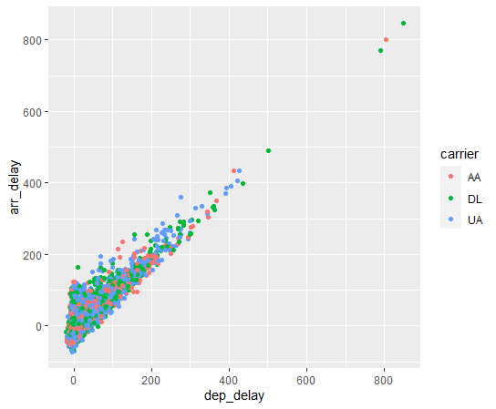

1. What are two aspects this plot does well, and what are two aspects that could be improved?